Software Requirements Specification
for
ONLINE DISCUSSION PORTAL
Version 2.0 approved
Prepared by
Shronit Bhargava
Siddhartha Kille
Sourabh Kaushal
Utkarsh Srivastava
Yatham Praveen

18th September 2016
Table of Contents
Table of Contents 1
1. Introduction 2
1.1 Purpose 2
1.2 Document Conventions 2
1.3 Intended Audience and Reading Suggestions 2
1.4 Product Scope 2
1.5 References 3
2. Overall Description 4
2.1 Product Perspective 4
2.2 Product Functions 4
2.3 User Classes and Characteristics 5
2.4 Operating Environment 5
2.5 Design and Implementation Constraints 5
2.6 User Documentation 6
2.7 Assumptions and Dependencies 6
3. External Interface Requirements 7
3.1 User Interfaces 7
3.2 Hardware Interfaces 9
3.3 Software Interfaces 9
3.4 Communications Interfaces 10
4. System Features 11

5. Other Nonfunctional Requirements 14
5.1 Performance Requirements 14
5.2 Safety Requirements 14
5.3 Security Requirements 14
5.4 Software Quality Attributes 14
5.5 Business Rules 15
6. Other Requirements 15

Introduction

Purpose
This software is generally a discussion portal which will be an integration to the NIIT UNIVERSITY’s present Moodle Web page. It is being developed to make discussions more open and information passing easier. Users login with their username and password and gets access to this portal.

Document Conventions
The following document is a concise representation of what the plan is all about in creation of the software.

The document contains a table of contents where we have mentioned what the document will contain.

The Document is typographically divided into Headings <Font Style-Times New Roman, Font Size -18,Bold>,Sub-Headings<Font Style-Times New Roman, Font Size-14,Bold > and detailed description in <Font Style-Arial,Font Size- 12,Italic >

Every requirement statement is in its shortest possible form giving a certain insight, and every requirement statement has its own priority.

Intended Audience and Reading Suggestions
The audience for our product are the students, faculty and all other existing NU MOODLE account holders.

The document can act as a insight to the web platform that is to be created and is meant for web developers looking on to basics and thorough summary of how to proceed in creating of online portals for discussions or creating posts.

Project managers who are in need of an online platform where his project members can discuss, Any person who wishes to use such discussion portals.

Documentation writers or bloggers who want to write articles regarding such web platforms.
The SRS is organized in way where we supply sufficient information so as to look upon the software and how it proceeds.

The manner in which a reader should proceed with this document is that he or she must be having the knowledge of basic terms about software and its creation

Product Scope
The project is being designed in such a way that all the students and teachers inside the university can discuss about the events that are to be taken place and information is required to be spread to all the members of the university.

The further scope of this product resides in the fact that this can be used by any team or residing group where it is impossible to go and tell it to everyone in person also where emailing is not such an optimized option.

This software will give a separate platform for such discussions giving it a more of profound and optimized implementation of the concept of giving out information to a mass.
This reduces the overthrow of vast emails that one receives every day
Creating such a forum can lead to a proper implementation of issues riding inside the university where response can also be given to the authority holder.

References

1. http://krazytech.com/projects/sample-software-requirements-specificationsrs-report-airline- database Overall Description
2. Software Engineering – Roger Pressman
3. Social Software – Bo Peabody
4. IEEE Std 8301998

Overall Description

Product Perspective
Inside the University campus there are a lot of activities taking place on a regular basis, and for every large and small activity taking place inside the campus there are emails referring to every activity.

The Admin is disturbed for every small activity that happens throughout the University be it things lost or found by someone to things where certain clubs have some kind of information to tell all people.

Our product is a platform where users can post and view stuff such as lost and found things and information regarding various things which is achieved by linking it with data base and will also get to know about the certain events happening within the campus. All users receive notifications which keeps them updated regarding the things mentioned above, this makes life easier and time efficient. This helps the people who don’t follow mails and are not active on social media and also will result in reducing the workload of the admin by getting rid of small posts like loss or finding of things inside campus.

Product Functions
The portal contains the following key features:

From User Side : -

- To Create a post regarding any issue like if :-

- If any student or faculty lost any this they can post on our portal and at the same time is anyone found anything they can take snap’s or video and upload in our portal for better description.so this increases probability of finding the lost item.
- We have several clubs in our university. So they have to communicate for any event they are doing .Therefore everyone in clubs should come and most the people may not have phone numbers of others members in the club.so if club head or anyone in the club will post on our portal. Hence problem solved.
- For organizing an event in the university we need volunteers and better ideas for successful event.
- We can create a survey post for conducting survey in our portal.
- For collecting feedback from student on any event.

- To Edit any post
- To Delete any Post
- View all posts posted by any user.
- Maintain User Profile.
- To Create any event.
- To Edit an event.
- To Delete an event.
From Admin Side :-
- Add User.
- Review Post.
- Delete Post.
- Reject Event.
- Send message to user.
- Delete Event.
- Edit Event.

User Classes and Characteristics
Mainly the User Class of our software are the students, and it can also be used by the teachers, staff and higher authorities. And any User class should not have as such any technical expertise to use this product but the ones who are developing needs to have a Technical expertise in many fields such as :-
- Any Coding Language.
- Database Design
- Doing the front end work, etc..

Operating Environment
This portal does not require any particular software components, applications and hardware. It will run in any browsing device with internet connection.

Design and Implementation Constraints
Implementation of No Due form filling form needs permission from the management of the organization as asks involvement of financial department and that indirectly accessing the financial database of the organization. We also have to take care of situations where spam posts are posted in the portal and how to prevent them. Another Problem is the notification of the new posts posted.
For this we would need some external software like Microsoft Visual Studio, Microsoft SQL Server Management Studio as we are thinking of doing our Front end through HTML, CSS, Javascript and Backend through C# or PHP.

User Documentation
We Will be delivering User manual which will act as a guide for the new user.

Assumptions and Dependencies
Initially We are assuming that we will be getting access to moodle service of our university and we will be able to integrate it in moodle. But if further some issues arise we can make it an independent platform.

Web Server Application is what the software depends on, and hence its functionalities affect the portal

External Interface Requirements

User Interfaces
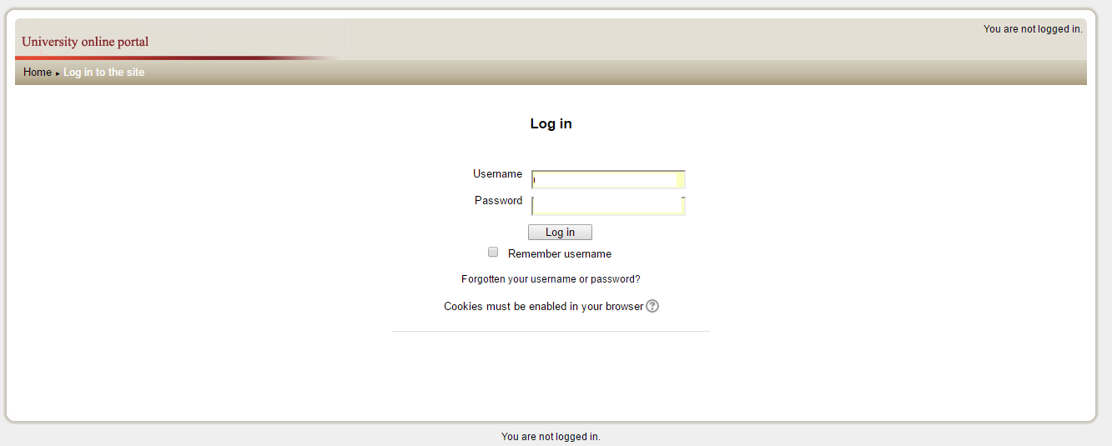
Below are the some UI’s which will work as motivation for us while designing

The Post Page
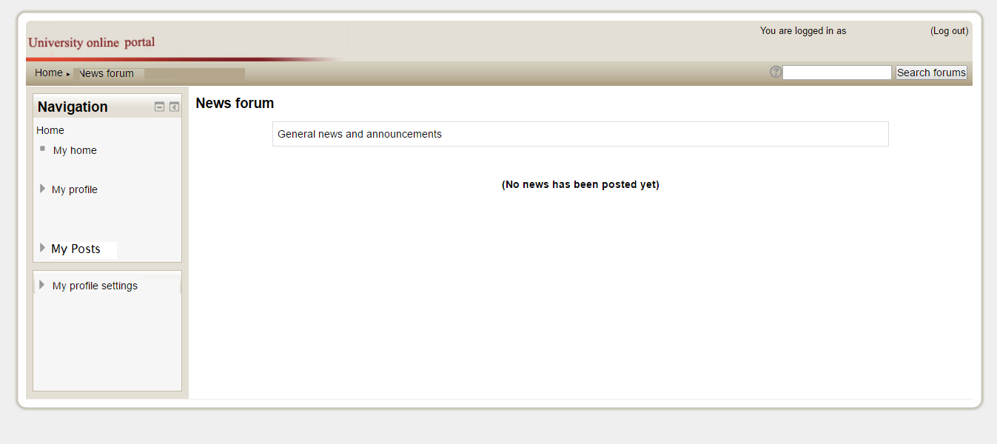

Maintain Profile Page

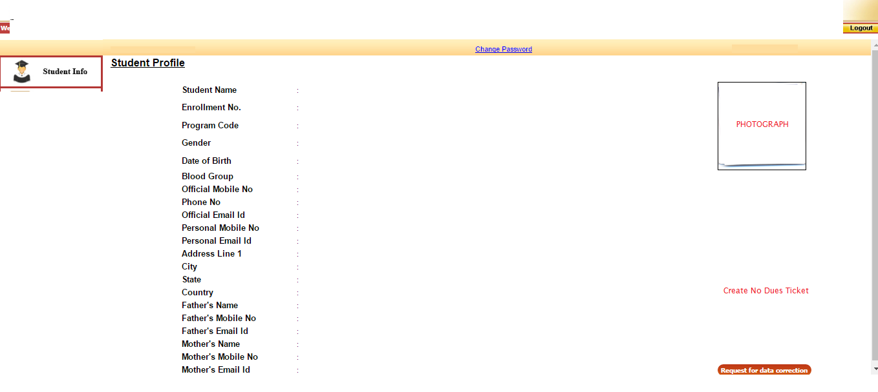

Event Ticket Generation
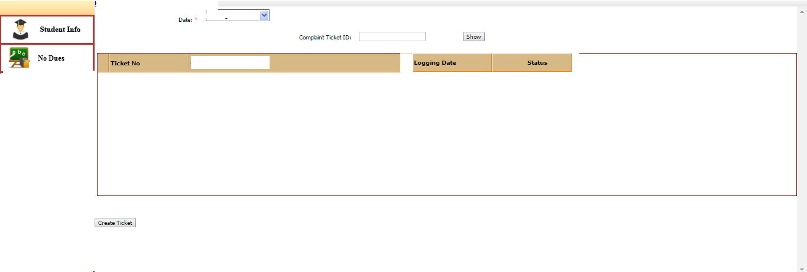

The system shall provide a uniform look and feel between all the web pages.
The system should use of the navigation bar and icons.
- First of all our User interface would be the Login Page from where only authorized person can get into our software, and if not authorized an error message would be generated inside the UI only of Unauthorized User.
- After that the User Profile page would appear where User can confirm his/her Profile and then proceed and also can update their profile and then proceed.
- After proceeding from the Profile page they would get land up on the home page where posts posted by different users will be posted would be there. Posts of some item lost would be provided by a Found button, clicking on which delete the post from our database. And also there would be tabs to navigate to the other services provided.
- Things Lost UI, where User can fill details of the item lost by them, and also possibly a picture if they have and the contact information also.
- Things Found UI, where a User have found something of which there is no lost post.
- Post, where User can fill the details of the post , which would be first sent to the admin for validation and then only will be posted.
- Event UI, where any user can post about any event happening within the campus which will include selection of the concerned department, event time and event venue which will be sent for the chain of approvals for posting.
- Admin will be given a UI for managing accounts for different users.
- Admin will be given a UI for the post and event approval.

Hardware Interfaces
Our product will work on any fully functional computer with minimal configuration and a properly working internet connection.

Software Interfaces
As such in our product we don’t need any external software, for Our product will need to have a database where we can store the post, where details of the pending dues will be stored, etc. and this database need to be connected with our product, for this we are using SQL Server Management Studio from where data can be accessed.
.

Communications Interfaces
The product requires the following:
- Web browser interface.
- Network Server for the admin and the database stores on the web server.
- Media attachment as an option to put on posts.
- Formatting post.
- FTP used for media uploads.
- HTTP for web network.
- Desktop or Home screen Notification System if required.
- MD5 Encryption or any other prioritized by the customer to secure website.
- Real time based Website.
- Synchronization of webpage with the server time.
- Proper Monitoring System.
- Penetration Vulnerability removal protocol.

System Features

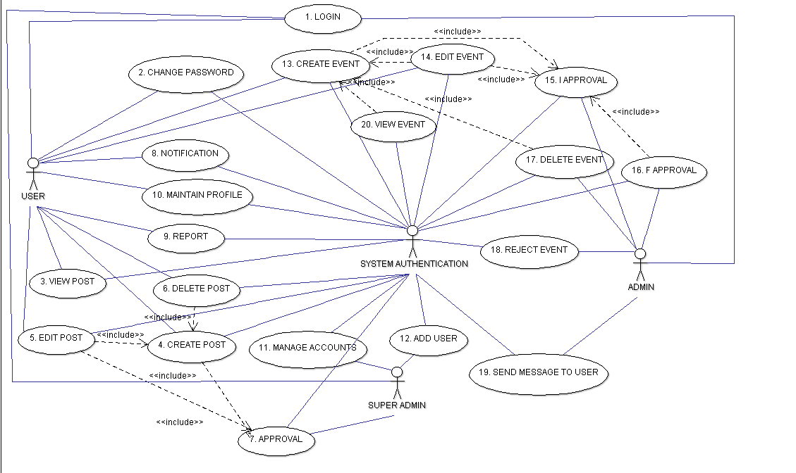
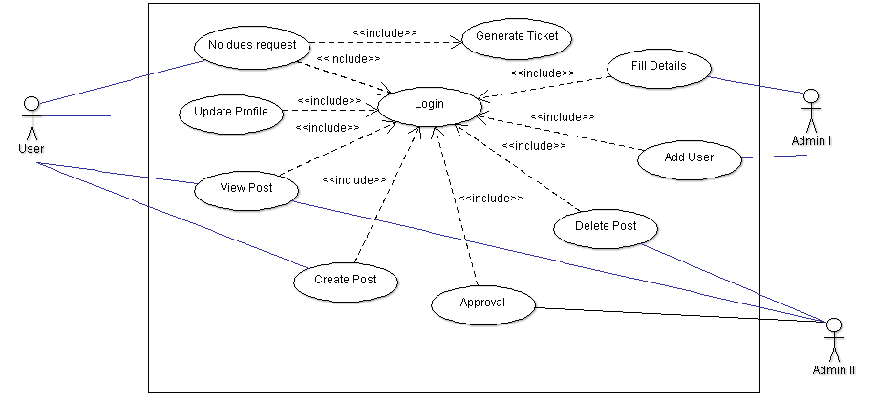
Requirement Id | Requirement Name | Description
R1 | Login | User, Admin needs to do login before doing anything.
R2 | View Post | Any User or admin can view the post about lost and found items.
R3 | Create Post | Any User can create a post regarding lost and found items which will be first approved by the admin and then posted.
R4 | Edit Post | Any User posted any post can also edit the post.
R5 | Delete Post | Any User posting some post can also delete that post, that post can also be deleted by admin.
R6 | Approve Post | Any post before posting is being approved by the admin.
R7 | Maintain Profile | Any User using this portal can maintain his or/her profile.
R8 | Remove User | Admin can remove any user.
R9 | Add User | Admin can add new users.
R10 | Report User | Any abusive thing can be reported to the admin by any user.
R11 | Notification | Any User using this portal will be notified for the new post.
R12 | Create Event | Any user can create any post for organizing any event, which will include adding date for event, venue for event and concerned department.
R13 | I Approval | Any event created needs to undergo chain of approvals, so it is the first stage of approval.
R14 | F Approval | Final Stage of Approval.
R15 | Edit Event | Any Event created can be edited by the user.
R16 | Send message to User | Any admin I Approval admin or F Approval admin can send message to user for any changes in the event. This can happen for any post also.
R17 | Reject Event | Any Admin can reject the event.
R18 | Delete Event | Any event posted will be deleted automatically after the event has happened.
R19 | Change Password/Forgot Password | Any User who wants to change their password can change it.
R20 | View Event | Any user can view the events posted by anyone.
R21 | Select Date | For posting any event user wants to select date for the event to happen.
R22 | Select Department | For posting any event user has to select a department to which approval will be sent.
R23 | Select Venue | For posting any event user has to select a venue where event will take place.
R24 | Edit Date | For posting any event user can edit date for the event to happen.
R25 | Edit Department | For posting any event user can edit a department to which approval will be sent.
R26 | Edit Venue | For posting any event user can edit venue where event can take place.
R27 | Send Approval to Admin | User trying to create any post or any event needs to send approval to admin.

Other Nonfunctional Requirements

Performance Requirements
Our Product should perform well in all conditions (i.e. should work on the PC with minimal configuration, should work when there is slow internet connection, our database size should be such that data don’t get overflow, our product should work well even when there is more traffic on the server instead of getting crashed.)
Product should be very efficient in informing the user regarding all the events and posts in the portal. If it fails there is no need for integrating it with NU Moodle, as many other options such as e-mail and other social media are at use..

Safety Requirements
- The database needs to be secure and only accessible to admin
- Loss of data is only possible if server fails or gets damaged and hence proper management of the server is needed
- MD5 Encryption and Encryption for server
- Penetration testing of the website can further help in making the website better
- Testing server and web for heavy traffic just to ensure that the server does not crash

Security Requirements
- The portal needs security features in order to secure the data
- Encryption needs to be done in order to maintain the website secure from hackers
- Proper Maintenance of the server is required.
- Only admin access should be encrypted
- Servers not accessible to all
- Privacy is to be there for every single user because he is supplying his information on his profile for his convenience
- Also the media being shared by the people needs to be secure so that it does not go into wrong hands

Software Quality Attributes
Our software must fulfill these attributes: -
- Adaptable: - Means it should adapt itself efficiently and fast to changed circumstances. It should be able to fit its behavior according to changes in environment or in parts of the system itself.
- Correctness: - Means it should always generate the correct results. There should not be any conditions which can alter the results and make them incorrect.
- Availability: - Means our product should be easily available to its customer.
- Flexibility: - Means it should have the ability to adapt according to some future requirements changes.
- Maintainability: - Means it should be maintainable i.e. in future if some changes are to be made, can be made easily, and should not change the structure or architecture of whole software.
- Testability: - Means that developers should be able to test the software easily.
- Usability: - Means that it should easy for the users to use.

Business Rules
Admin will identify the spam posts and event, inform the user who has posted it. All the posts will be deleted from the wall after resolving or certain amount of time, this is taken care by the developers during the development of software. All the feedbacks and complaints should be acknowledged and action must be taken as soon as possible.

Other Requirements
As of now there are no such other requirements according to us if further comes can be added to the system.

